Fit Fortis (Codename)

A Web Site for Personalized Health Tracking, v0.7

Table of Contents

1. Introduction 2

2. Product Overview 2

3. Design 3

3.1. Design and Visual Requirements 3

3.2. Proposal 3

4. Web Site Structure 5

4.1. Basic Structure 5

4.2. Prototypes 7

# 1. Introduction

This document captures the basic requirements for the web site for personalized health tracking, to enable generation of proposals.

# 2. Product Overview

Fit Fortis (FF) is a web site personalized health tracking. It provides a beautiful and functional experience with the following capabilities:

* The site is a **One-Stop Shop** for all of your health-tracking needs.
* The **Smart Dashboard** allows you - the user - to track various metrics and health indicators. The dashboard also enables the user to derive correlations between different health metrics by making use of AI and ML.
* A secure **Document Vault** provides storage and retrieval of health-related documents, and the ability to generate health reports on demand.
* The user can connect the site to **Devices** collecting health information (e.g. a smart scale, an Apple Watch, etc.)
* The site also provides a **Health Encyclopedia**, which provides information about various health-related metrics and indicators (e.g. blood glucose, BMI, etc.). The health encyclopedia also has a symptom checker.
* The user can record their personal, hereditary and genetic information in their **Profile**.
* The site also provides **News & Alerts** personalized to every user.

The site is designed with security and data-protection in mind. All data is encrypted and all access to data is audited.

# 

# 3. Design

## 3.1. Design and Visual Requirements

1. The site should have a simple, clean, and modern look.
2. The site should be colorful, visually engaging, and fun to use.
3. The design should evoke “health” (but not “hospital” or “clinic”, which is associated with “sickness”). The design should evoke “strength”, “tracking”, “intelligent control”, “dependability”.
4. Complex information should be presented in the simplest way possible, but not simpler.
5. Color should be used with intent and should aide the cognition of the data.
6. Same applies to typography.
7. Consistency of elements, to reduce cognitive load.
8. Recognizable, and unique brand. Think disruption through color, advanced visualization, intelligent control and intelligent data management.

For example, see [these charts](https://vx-demo.now.sh/gallery). They are modern, bold and colorful, yet comprehensive and usable. That’s the ethos we are trying to strike.

## 3.2. Proposal

As part of the interviewing process, we ask designers to submit a **design proposal**, covering:

1. 2 representative screens of the web site;
2. 1 of the screens should show the **smart dashboard** showing 4 measurables, tracked with different granularity (see below for details);
3. Feel free to use annotations to explain the design proposal;
4. Clearly explain the color palette and the font size palette.
5. Ensure that the shown elements are real and thought out and can be implemented as is – this way we know the design is viable. **Don’t go too conceptual**
   1. E.g. a chart view should be very simple but still usable. You should not have several profiles. There should not be extraneous information such as multiple profiles, online presence, etc. that’s not in the spec below.
6. Do ask us questions, and/or challenge assumptions. We believe that Design is a collaborative process, involving some “productive conflict and agony” :). This collaborative process produces great, simple, beautiful and delightful solutions to real human problems.

# 4. Web Site Structure

## 4.1. Basic Structure

**Important**: This is a VERY preliminary structure. We encourage ideas to optimize and simplify it. For example, it’s unclear whether we need to have a separate “News & Alerts” page, as we could have that functionality on the home page. The relationship between Documents & Profile is also not very clear. Perhaps they should be a single page… And so on.

|  |  |
| --- | --- |
| Screen / Functionality | Description |
| Sign-up / sign-in | Ability to sign up and sign in with Facebook login, Microsoft account and email + password. |
| Home | The initial landing page of the site, combining key information from the other pages. |
| Dashboards | **Dashboard --** A core part of the web site is the so called “smart dashboard”. The smart dashboard is a screen, which contains one or more configurable charts. The “x” axes of the charts is almost always time, and the “y” axes can be configured to be one or more trackables.   1. Several trackables can be superimposed on a single chart, in which case they get displayed as different axes ([example](https://vx-demo.now.sh/axis)). 2. The user can also add additional charts under the current chart and display trackables there (so that one chart doesn’t get overwhelmed with too much information). All added charts are horizontally aligned. 3. The charts can display annotated data points ([example](https://vx-demo.now.sh/areas)) 4. The charts allow annotations ([example](https://vx-demo.now.sh/glyphs)) -- the user can add additional annotations (e.g. doctor visit, lab results, started a new diet, etc.) and they can get shown / hidden on the chart 5. The charts allow zooming in and out and panning ([example](https://www.fusioncharts.com/fusiontime/examples/plotting-two-variables-measures)), and selecting date/time ranges. 6. The charts can also show reference lines and intervals for variables (e.g. blood glucose should be between 79 and 110 mg/dL, etc.) 7. The tolerance intervals should be configurable (for age, race, etc.) 8. The user should be able to see chart data as a table too.   **Suggested correlations** -- The system should provide assessment of the correlation of the displayed measures on the chart. (E.g. “The data suggests a strong correlation between blood sugar and blood pressure”, etc.) This should be shown |
| News & Alerts | A screen where the user can see a newsfeed of medical news related to them, as well as specific alerts related to them (time to go to the doctor, etc.) |
| Documents | This is the **Document Vault** -- provides ability to store and retrieve / print medical documents, such as lab test results   1. The user should be able to print individual documents. 2. The user should be able to select documents by their date. 3. The user should be able to generate / print a health report for a selected period of time (e.g. for the past 6 months, or for the past 2 years) which would contain all relevant documents as well as charts from the smart dashboard. This would allow the user to visit their medical doctor prepared.   **Ability to generate a health report**   1. The user should be able to generate a health report (print, or as a PDF) for a specific time frame. The report should contain representative charts, as well as printouts of the documents in the document vault, that apply to the selected time frame. |
| Devices | Ability to connect / disconnect / configure wearables and other devices collecting medical and physiological data (Apple Watch, Fitbit, a smart scale, etc.). Any connected device can provide measurements to the web site. E.g. an Apple Watch can be used to provide daily measurement of heart beat, blood pressure, a smart scale can provide weight measurements, etc. |
| Encyclopedia | **Encyclopedia** -- This is where the user can find information about metrics, lab tests, etc. It's also probably the screen, which is the entry point to a symptom checker.  The user would be able to come to this screen and do research, from the smart dashboard.  **Symptom checker** -- ability to look for symptoms and get diagnostic analysis. |
| Profile | **Profile** -- ability to record basic profile information:   1. Username, email & password 2. Name, DOB, sex, ethnicity, photo 3. Medical profile information (family history, genetic information, chronic conditions) |

## 4.2. Prototypes

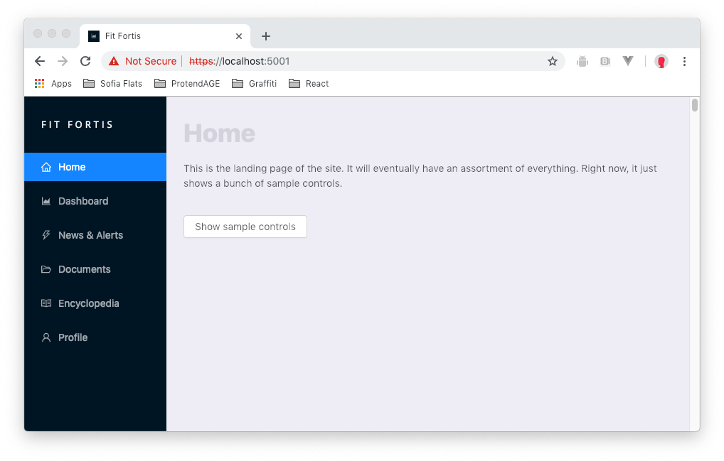

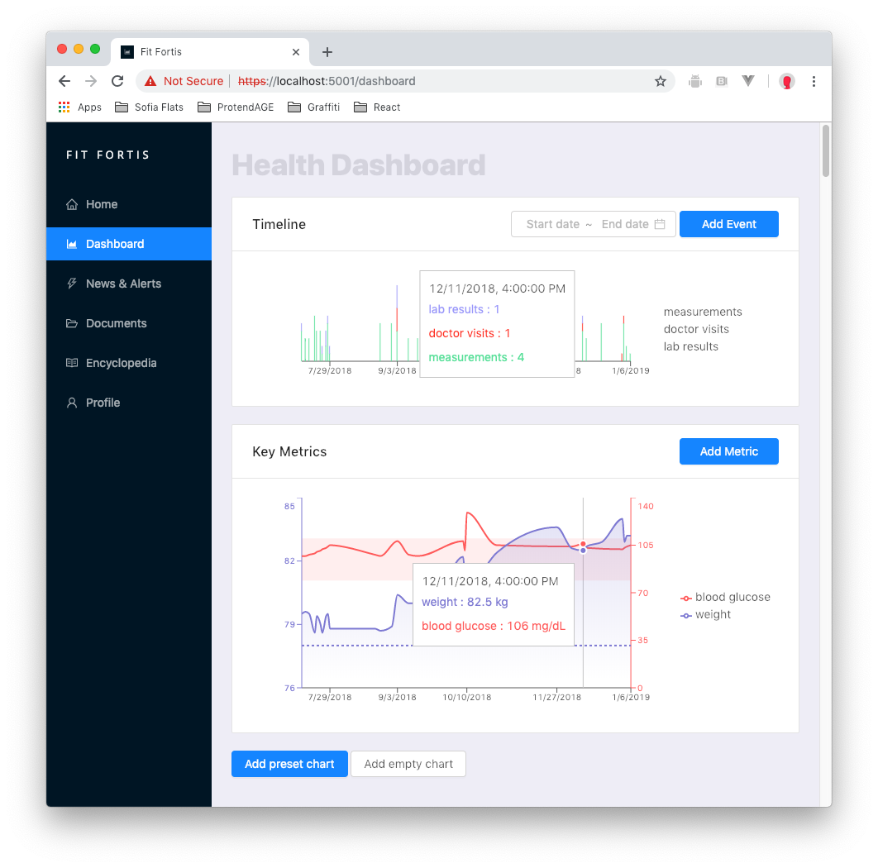

Here are some additional variants of the **smart dashboard** screen. Demonstrating the timeline, key metrics (showing, hiding a metric, seeing more information about a metric and configuring a metric), etc.

